**HACKEAM 2018 STATEMENT OF RESEARCH**

**Abstract**

The following research paper serves to demonstrate the findings of a research trek conducted in Goyla Dairy Farms, Dwarka, New Delhi in a structured manner that highlights the intricacies of current rural mind-set as well as the upcoming needs that can be addressed using software technologies. It is assumed to a certain degree that potential targets of the upcoming product based on this trek, do have access to smartphones and possess basic knowledge of their usage. The video footage of the trek will be promptly furnished on request. The rest of this paper aims to highlight details of the information gathered from locals of the area and how it can be helpful in moulding our application according to the specific needs of the farmers and local labourers.

**Introduction**

Upon visiting the aforementioned location and discussing with the locals about current scenario in agriculture and farming techniques, a plethora of issues came to the foreground that may have unfortunately gone unnoticed. The details of these are listed below:

1. Irrigation from unhygienic sources // ADD DETAILS LATER
2. Labour demand and supply
3. Seed pricing
4. Fertiliser consumption
5. Uncertainty in output of farm

The above list is tailored to the capabilities of computer scientists such as ourselves and therefore excludes items such as machinery related issues that are no less of a problem but cannot be addressed by us for the sake of this project. We do understand that the 5 problems mentioned above can be addressed using relevant software but as any other technology, our application will focus on providing a means for farmers to bring about change themselves and is not a binding way to ensure that automatically. With the adoption of the application and its regular usage, however, we aim to ensure a more convenient daily response to their struggles while addressing some major health concerns put forth in point 1 and 4 above. The structure of the application we aim to build is laid out in the remainder of this paper, followed by a conclusion that elucidates our intentions pertaining to the features that we add.

**The conversation that took place:**

As we trekked into a huge farm in Goyala Dairy, a semi-rural area in the outskirts of Dwarka, we met Gopal Singh Kushwaha, a menial hire working for Jaipal Singh, the farmer and the lord of that land. We conversed for over an hour with the two of them, our major focus being interacting with the farmer himself, Jaipal , who irrespective of being very humbly literate, had a smartphone and active internet that he knew how to use, and use well.

A vivid account has been presented hereunder. Additionally, we have recorded videos of our discussion that can be found embedded in our website <>  that we especially hosted to supplement and corroborate this paper. We humbly request the jury to find time to peruse that as well.

**Q. 1. What a kind of crops do you grow and what are your farming practices?**

A. We essentially grow vegetables – tomato, cauliflower, radish to name a few. Most of our farming makes minimal usage of chemical fertilizers and pesticides because I’ve found on internet about how harmful their overuse can prove to be. Additionally, I wish to shift to organic farming in the near future, another thing I found on the internet.

**Q.2. Do all farmers have similar practices around? How aware and informed do you think they are?**

A. Though I do my part in generously sharing all the useful information I gather about farming, the extent of awareness among my fellow farmers is still pretty less despite having equal access to smartphones and internet. Primarily so because many of them are indulged in dishonest means of quick money-making. Not only do they overuse chemical fertilizers and pesticides, but also they have foul irrigation practices like using filthy sewage water for irrigation which is a malpractice particularly rampant in many areas across Delhi.

**Q.3. Will you be willing to report all these things so that something can be done?**

A. Anonymously, yes.

**Q.4. What other problems do you face in farming that you’d like to be addressed?**

A. Laborers are extremely hard to find. In fact, it is lack of availability of laborers that is, in fact, discouraging farming among people today. Our crops need timely care which requires manpower the lack of which amounts to heavy losses to the farmer, hence discouraging them to practice agriculture.

**Q.5. Where do you buy seeds, etc from and where do you sell your product?**

A. There are various shops in and around Dwarka, Najafgarh, etc that sell seeds, fertilizers, pesticides, machinery, etc. I’ve also purchased a heavy machine online for tilling my land. As for selling my products, Gopal and  a few other men I hire take these fresh vegetables in bulk on a trolley to one of the many nearby markets.

**Q.6. Are there disparities in prices across markets (of both seeds and the crops)? Would you like something to be done about it, like if we could get your phone to know the minimum seed price and maximum ongoing rates in nearby vegetable (mandi) markets?**

A. Yes, why not! *brightens up*. It will be a great help for us!

**How we aim to solve the problem?**

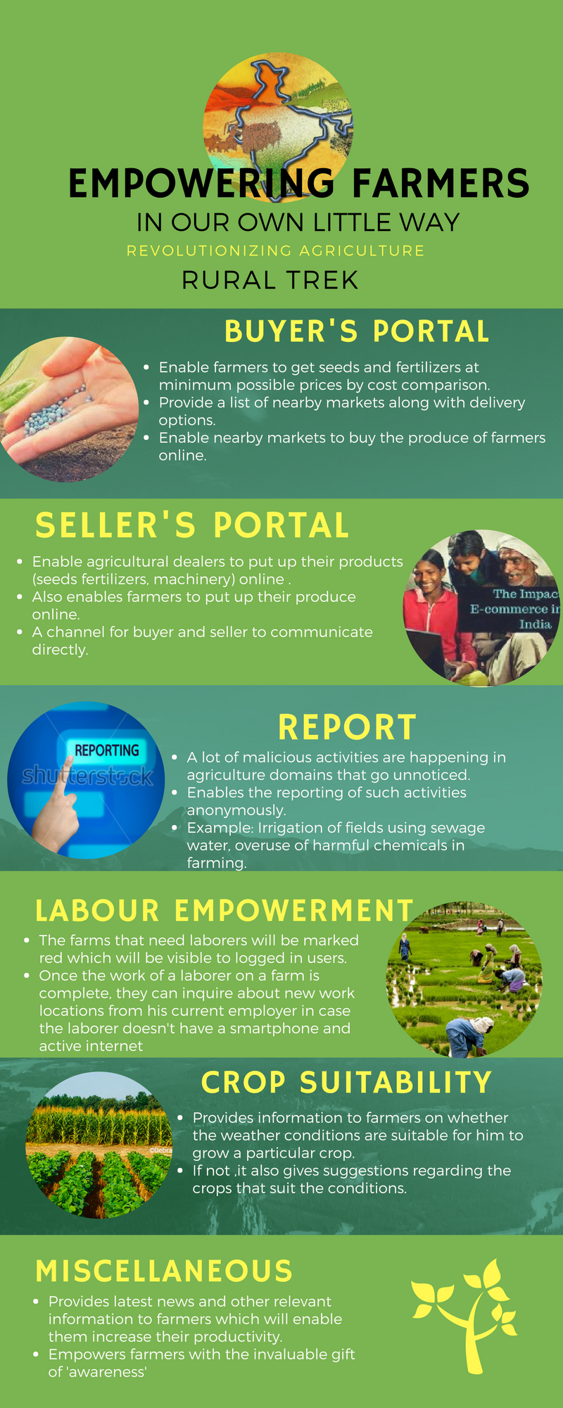

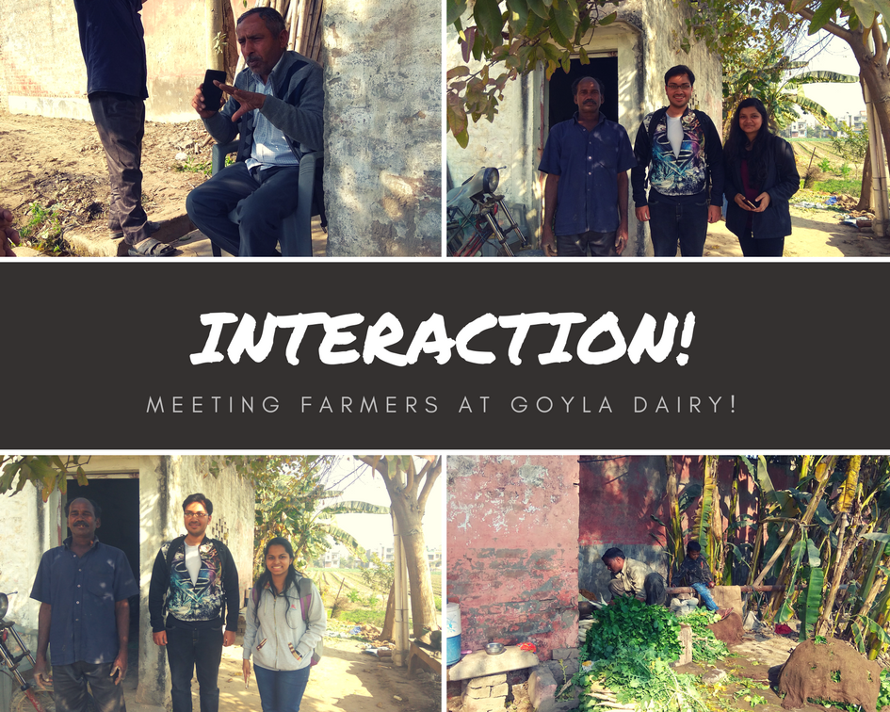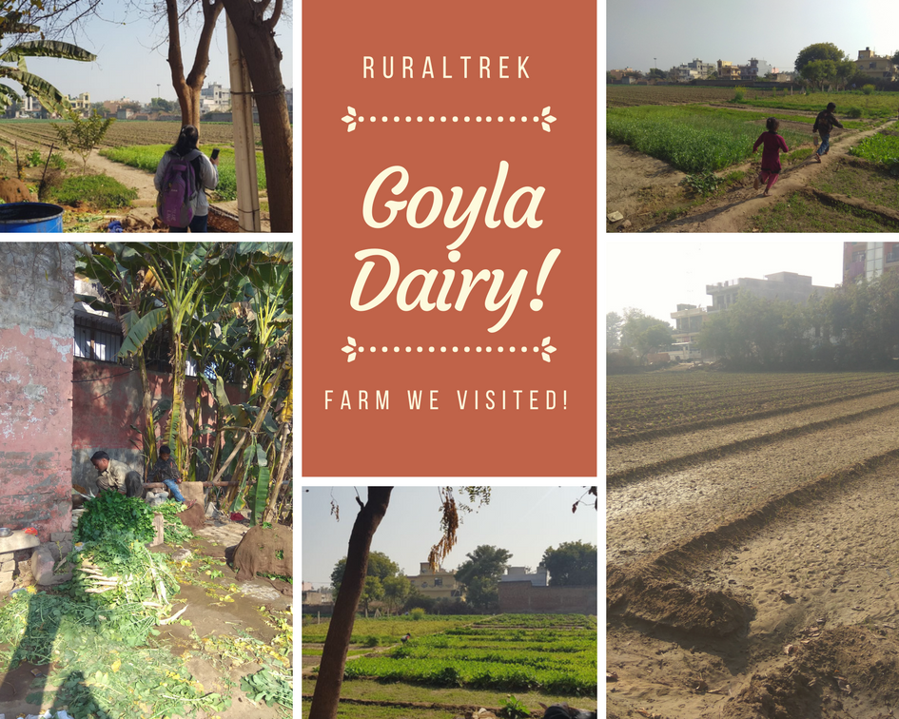**An insight into the visit:**